Context and Structure: The RTS

Scope
The thesis does not address in any detail the role of traffic management or infrastructure, but points of interoperability can be inferred.

The UIC vehicle as identified in the Law Commissions’ recommendations (Law Commision of England and Wales; Law Commission of Scotland, 2022) is outside the scope of this thesis representing as it does, an RTS equivalent of potential stochastic terrorism or a lone wolf attack where the terrorist is defined as a physical driver acting outside predefined behavioural norms for the autonomous vehicle. Consideration of the cyberphysical and ‘other road users’ are in the same category with respect to unpredictability. The rules for their behaviour cannot be guaranteed.

It is not certain that the cyberphysical, UIC and NUIC, otherwise known as an autonomous vehicle (Law Commission of England and Wales; Law Commission of Scotland, 2022), can operate contemporaneously due to the number of stochastic or random events to which an autonomous vehicle will need to be programmed to respond. With respect to ‘other road users’, behaviour is thought to be culturally informed, but there is no guarantee that it can be constrained, even within those bounds. This presents as an interesting policy point and future infrastructure planning point, but is outside the scope of this thesis. In order to render the problem of scaling in the RTS and determine a solution for operational autonomous vehicles, it is necessary to extract the essential contribution of communications to the goals of the RTS and contributing functionality of an autonomous vehicle, defined by its purpose, and place within the RTS.

Introduction
Chapter 1 spent much time discussing context. The context in which to identify and evaluate the challenges facing the scaling and deployment of autonomous vehicle arises from defining the field of operation of those vehicles. To do this, it is necessary to identify the essential component parts of the RTS and to elucidate the operational characteristics of autonomous vehicles. These activities will go to simplify development, necessary communication and interoperability requirements for domestic and non-domestic authorised vehicles.

Using the purpose and goals of the RTS as a starting point, logical analysis provides that within the RTS there are static and dynamic components. The static components can be updated by a prescribed organisation in a manner agreed with the overarching authority, in this instance, the Secretary of State for Transport. From this it can be inferred that the static components do not change in a short period of time, contrary to the dynamic components which are linked directly to the actual operation of autonomous vehicles.

The components identified can be divided between prescribed organisations, attributing responsibility and accountability for those components. This may naturally fall to those organisations having legacy systems addressing those components of the RTS. It is asserted that the ownership, creation and maintenance of the knowledge bases essential for autonomous vehicle operation will have similar protocols applied.

It is a frequent mistake in any primary analysis to consider other than the base case in which everything is well defined and operating within its specified behaviour when establishing a complex system. Here, there is no consideration of system sophistication outwith that base system.

Any such consideration of other than the base case is seen as an extension to the system – scenario development belonging to the ‘what if?’ set. The original specification must be based on ‘what is supposed to happen when the system is operating correctly?’. As Milner (2009) states when discussing such stratification, one can at least make proposals about the possible ingredients of a structure, without being bewildered by the immense range of behavioural qualities that it will support.

Methodology
The context in which autonomous vehicles will scale is lacking. In an attempt to define that context, the initial approach taken is the use of cybernetics.

A number of definitions are available at the American Society of Cybernetics (ASC), simplistically, “Cybernetics seeks to develop general theories of communication within complex systems. … The abstract and often formal mathematical nature of its aims….”Invalid source specified.. It is concerned with what is done; how it is done or achieved is irrelevant Invalid source specified.. It derives from consideration of the organisation to be found in complex systems (Heyligen & Joslyn, 2001). Cybernetics results in models which can be used in an ontogenetic manner (Kherissi & Meslati, 2010) that permit systems to evolve over time to achieve their specified goals in the light of experience (Almaguer-Kalixto & Giglietto, 2019).

Cybernetics is primarily concerned with how systems function, use data/information, and exercise control to achieve and maintain the goals of a system. It is a cross-disciplinary approach which can be applied to any type of system. The linkage between the virtual and real, and cyber space to cybernetic space is discussed in Mitra and Schwarz (2001). This is a pertinent discussion as the representation of those things linked is not necessarily congruent while achieving the same objective. This indicates that any proposed solution which will be implemented virtually does not need to look like the reality to which it linked.

Second-order cybernetics recognises that the definer of a system is themselves part of the system (Umpleby, 2016) The RTS problem, identified in Chapter 1, tackled by another person could have a completely different valid axiom system. This uncertainty of a unique finding is commonly understood in anthropology where differing participant-observer roles can lead to different understandings of the society being researched (Explorable.com, 2015), likewise qualitative research Invalid source specified., Invalid source specified.. In recognition of that fact, the author puts forward an axiom system based on personal experience, observation, and the operation of personally determined logic.

Gazing into the future in an attempt to pre-empt potential issues will always have its shortcomings and errors. This thesis is no different in that it represents an interpretation of the imagined, but considered future when the deployment of autonomous vehicles has scaled.

Purpose and goal of the RTS
There is recognition that purpose and goals of an RTS may not be consistent, and that some definitions of infrastructure comprising the RTS may not be acceptable across all nation states. Interestingly, there is not a single definition for the purpose of a unified RTS. While this is a logical assessment of the RTS, there are numerous sources which have defined their specific area of the RTS, from its operation (Road Networks Operations and Intelligent Transport Systems, n.d.) to its role in society (Engstrom, 2016). Matthew (2019) shares the UK Government’s perspective: Transportation affect[s] the growth and changes of socio-economic system, and … triggers changes in transportation system.

Counter to the discussions in The Geography of Transport Systems (Rodrigue, 2020) there is a possibility that the advent of the autonomous vehicle may make society less free and mobile. The logical conclusion for the autonomous vehicle is that it operate without a predefined destination. Choosing a route is a combination of the possible from the navigation system constrained by the physical infrastructure, to the actual, determined by the traffic management system. The occupant of the autonomous vehicle has little to no control over the vehicle, other than to provide a destination and commands to stop, go, or change route. The days of getting lost and serendipitously finding new places which are pleasing and worthy of another visit, or aimless, meandering Sunday afternoon drives could be gone forever.

In order to reduce the complexity of the RTS, it is necessary to revert to first principles and understand the purpose and goals of the solution. Without knowing purpose and goals, the parallel is similar to testing a system against a non-existent requirements specification. How would you measure its success? It is not possible to validate or evaluate any proposed solution for the RTS and its components without a context. This validation will be a necessary requirement for any deployment as evidenced by (HM Treasury & National Infrastructure Commission, 2024), a 12 month study into identifying the incremental steps and interventions that may be required on the road network… an adaptive strategy…additional policy.., infrastructure requirements, regulatory, safety, and legislative framework

The purpose of defining a graphical structure is to provide the scaffolding which supports the resultant axiom system for those with a lesser familiarity of logic and mathematics. It is a conceptual representation of the RTS, that takes into account the purpose and goals of the RTS in which automated and autonomous vehicles operate, thereby defining the context for vehicle operation. Potential required points of interoperability and communications which are the subject of international negotiation can be identified.

The structure of the RTS and definition of the role of vehicles within it, deriving from their contribution to the purpose and goals, should highlight the need for interoperability and consequentially, the system development, policy, and regulatory and legislative issues necessary to be in place before unleashed autonomous vehicle operation commences. The autonomous vehicle is not a special case. The identical exercise is required for any interconnected or intersecting system, including: authorisation authorities, registration authorities, operational authorities, first responders, traffic management, navigation systems and cyberphysical or UIC vehicles.

The aviation industry has experience of treaty negotiation to overcome jurisdictional and international differences in operation and issues of scaling. The Automotive industry would do well to review the current Consultation Paper addressing Aviation Autonomy (Law Commission, 2024) during its own consultation period (HM Treasury & National Infrastructure Commission, 2024) and before arriving at any solution.

The purpose of the RTS
It is posited that the purpose of the RTS is to provide a mechanism for:
- Purposeful transportation
- Free flow of traffic
- Safety of operation

The goals of the RTS
Where traffic is comprised of a vehicle, a group of vehicles, or groups of groups of vehicles, the question arises as to ‘What are the contributions elements of the RTS can make to the goals of the RTS?’. They can be stated thus:
- efficient operation of purposeful road traffic
- effective operation of road traffic within the infrastructure
- safe operation of purposeful, operating road traffic entailing:
  - Predictable behaviour
  - Avoidance of damage:
    - To occupants of the vehicle
    - To objects in the environment
    - To other vehicles

Purposeful, in this context, is defined as being on a journey from A to B and arises from the navigation system. The source of the journey is the current location of the vehicle, while the destination is where the occupant of the vehicle wants to be. The rationale for making the journey is not a consideration of the RTS, although it may be of consideration to the Traffic Management system, which presents as a Data Protection Act 2018 concern for individuals. This concern may be obviated in the context of business and freight operators, while containing proprietary commercial information, the information may ultimately be useful in groupage, efficiency and economics.

It immediately becomes obvious that autonomous vehicles are a component of traffic and that their behaviour must be circumscribed. Predictability does not simply relate to connected object behaviours including vehicles. There are other users in the RTS based on the historical development of infrastructure and means of mobility. The disparate users and need for predictability can be exemplified by consideration of pedestrians and their expectations of vehicle behaviour, as will be discussed in Chapter 5 Mathematical Representation of Knowledge and Predictability for the Autonomous Vehicle in Operation.

The causes of the scaling problem
There are two discrete elements of the scaling problem.

The primary cause of the scaling problem
It is self-evident that the incentive of market domination is the economic force underpinning the manufacturers’ commitment to the development autonomous vehicles, encouraged by the UK Government (HM Treasury & National Infrastructure Commission, 2024). They are behaving as the prime movers of introduction and deployment without any operational context, perhaps in the hope that the Betamax versus VHS scenario (Logie, 2020), (Williams, 2023) will favour their proprietary solution if they get there first, can market successfully, and manufacture in sufficient volume. Convenient eradication of competitors along the way is not a novel business strategy as evidenced by Tesla (Epp, 2023).

Game theory is very much a part of scenario development for autonomous vehicles, and is useful demonstrate the primary cause of the scaling problem. Rather than theoretical Game theory, it is possible to couch the primary scaling problem in terms of Monopoly™ as shown in Figure 10. Quite literally, using the Monopoly™ analogy demonstrates:

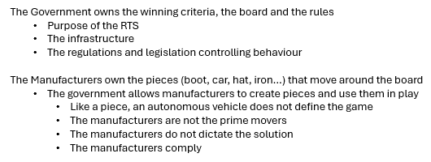
Figure 10 The primary cause of the scaling problem

The secondary causes of the scaling problem
There are other problems to be resolved before autonomous vehicles can be deployed as indicated in Figure 11. It should be noted that apart from developing without context, and the autonomous vehicle specific requirement for cyber security, the causes are not within the domain of the manufacturers. These are subject to policy and regulation, even with regard to the Motor Insurance Bureau and its requirements. The government has not seen fit to address any of these elements in the Automated Vehicles Bill [HL] (His Majesty's Government, 2024) which has left the Motor Insurance Bureau with incalculable risk assessment concerns (Thales SIX UK, 2023), (Thales SIX UK, 2024).

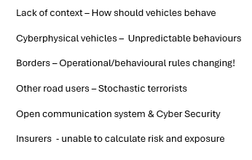
Figure 11 The secondary causes of the scaling problem

Graphical representation of the essential RTS components

Static elements of the RTS
Considering the purpose and goals of the RTS, the following minimal components as shown in Figure 12 of the RTS have been identified. Second order cybernetics (Foerster, 1995) dictates that bias is present in the analysis, and another person could determine a completely different, yet still operational structure which would address the problem of scaling satisfactorily.

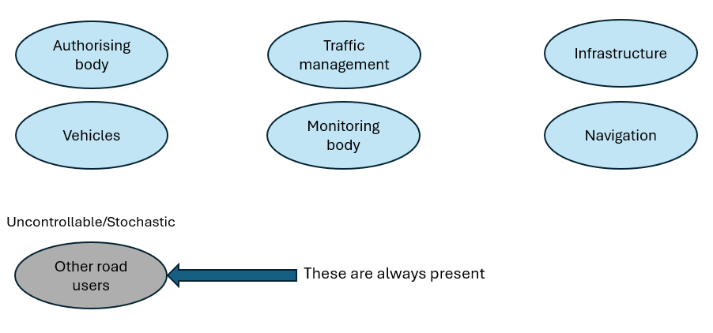
Figure 12 The essential components of the RTS
It should be noted that all components, with the exception of the monitoring body, are effectively black boxes and composites with legacy or other proprietary systems. For example the Authorising body in Figure 12 will comprise a specialist organisation addressing authorisation of automated and autonomous vehicles, and an organisation similar to the Driver Vehicle Licensing Agency (DVLA) which fulfils a different Governmental and administrative role in respect of vehicles permitted to operate within the RTS. Of these components, the DVLA has legacy systems and functions and it is not known by either the Government (HM Treasury & National Infrastructure Commission, 2024) or the author precisely what will be required of the actual authorising body whose actions will result in approval or otherwise, of an autonomous vehicle to operate in the RTS.

Loosely referred as Traffic Management in Figure 12, it is anticipated that the function of this component of the RTS will examine in real time the volume of traffic at points in the infrastructure and via the infrastructure communicate with vehicles to achieve free flowing traffic and effective use of the infrastructure during times of heavy volumes. Resulting from this will be an extension of the infrastructure planning activity.

The navigation component in Figure 12, is independent. Choice of navigation system is due to the manufacturer. It is anticipated that active navigation is beyond the base requirements of the autonomous vehicles operating in a prescribed environment, and that the method of navigation indicated in Chapter 2 Methodology: Mathematical Representation of the Autonomous Vehicle would be necessary and sufficient to fulfil requirements.

Need for the monitoring body, shown in Figure 12, for automated vehicles operating an autonomous function and autonomous vehicles is dictated by the Automated Vehicles Bill [HL] (His Majesty's Government, 2024)

Knowledge Bases essential for the RTS
As shown in Figure 13, the minimal number of knowledge bases are divided between static, containing stable knowledge and dynamic knowledge pertaining to the actual vehicles in operation.

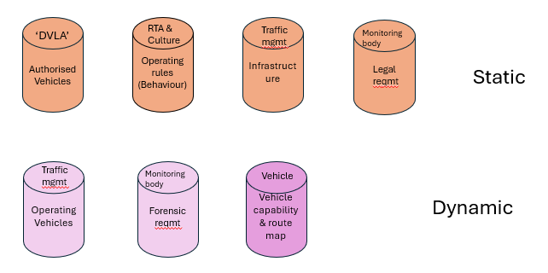
Figure 13 Static and dynamic knowledge bases of the RTS
In Figure 13 the knowledge base identified as DVLA is as discussed under Figure 12 in relation to the authorising body. There is a record of pairing of each authorised autonomous vehicle and its monitoring body. For a vehicle to operate, its identifier must be contained within that record and the monitoring body with which it is associated must be approved. The Automated Vehicles Bill [HL] (His Majesty's Government, 2024) indicates a connection between the monitoring body and the autonomous vehicle must be initiated and operational prior to the autonomous vehicle commencing on-road operation. Although a logical requirement, this requirement has unintended consequences.

The RTA and cultural knowledge base is associated with Road Traffic Acts (RTA) and other relevant legislation, and the more difficult element of cultural expectations of behaviour and other road user expectations. It is through reference to this knowledge base that the behaviour of an autonomous vehicle and responses to scenarios are defined, a direct contribution to the safety goals of the RTS.

As discussed in Figure 12, the static traffic management knowledge base holds the knowledge concerning the infrastructure. In enabling free flow of traffic, the traffic management system must be aware of the volume of traffic at any point in the infrastructure and be able to use that knowledge to direct traffic to alternative routes to avoid traffic jams. The resultant actions enable the efficient flow of traffic and effective use of the infrastructure, a direct contribution to the goals of the RTS.

The static knowledge base of the monitoring body is the permanent record of journeys and effectively contains the history of each autonomous vehicle for which the monitoring body is responsible. This distinguishes it from the dynamic monitoring body which is the real time monitoring and recording of the autonomous vehicles for which the monitoring body is responsible current journey. According to the Automated Vehicles Bill [HL], these will be replicated for each monitoring organisation authorised by the ‘DVLA’.

The operational structure of the RTS and its communications
It is recognised that communication needs to be as efficient as possible and that there are a number of technological solution dependent on the need for speed, resilience, and cyber security. The operating structure given in Figure 14 enables a variety of communicating technologies that will be most applicable in the circumstances. This is an essential consideration as decision making in real time while at potentially high velocity creates a limited response window for any given scenario. An example of decision making is given in Appendix B Complexity and the importance of time.

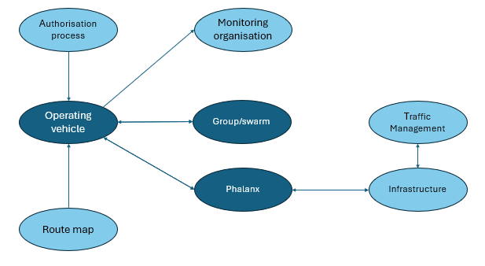
Figure 14 The operational RTS and its communications
It can be seen that two additional components have been created, the Group and the Phalanx. These will be described in detail in Chapter 7 Scaling Safety: The Operating Vehicle World: Specifications and Functions, but here, it is perhaps sufficient to say that the group is finite in number and exercises swarm behaviour, using Vehicle to Vehicle (V2V) communication to avoid collisions. The Phalanx describes exactly the same vehicles but as seen from the perspective of the Traffic Management system. Communication to and from the Traffic Management system is via the Infrastructure. Their introduction serves different roles in the RTS and is due to consideration of communication efficiencies and time sensitive data flows required for safety; for example, the need to avoid collision with another vehicle has greater priority than the need to avoid a traffic jam.

Other elements in Figure 14 have been discussed previously. What is not included in Figure 14 is Navigation and the communication of a source and destination by the autonomous vehicle for a journey which results in a route map. This is addressed in Chapter 6 Scaling and Safety: Autonomous Vehicles World: Specifications and Functions.

Communication sets essential for the RTS
The solution proposed here is that the RTS is a closed system, making cyber security a more tractable problem as what is to be defended is known. Table 3 shows the suggested minimum number of communicating sets, though each set is either potentially large or highly dynamic. While manufacturers continue to use the term V2X indicating vehicle to everything communication, this cannot, in reality, be the case.

There are three contributors of extreme relevance to the cyber security of any part of the critical national infrastructure of which the RTS is a part. This thesis acknowledges the impact of Sun’s (2010) quotation concerning self-knowledge, Mueller III’s (2012) speech concerning the extent of hacking, and statistics with respect to the speed of successful hacking by nation states. Because cyber security threats arise from unknown sources, we can conclude that at best, the RTS will succumb to 50% of cyber attacks and if it is a nation-state doing or sponsoring the hacking, their success will be achieved quickly (Jackson Higgins, 2019). The success rate of individuals is unknown and incalculable. Digital and cyber security are discussed further in Chapter 9 Digital Security: Fortified Cyber Defence, Resilient Cyber Defence and Trusted Autonomous Systems.
Table 3 Where is V2X?
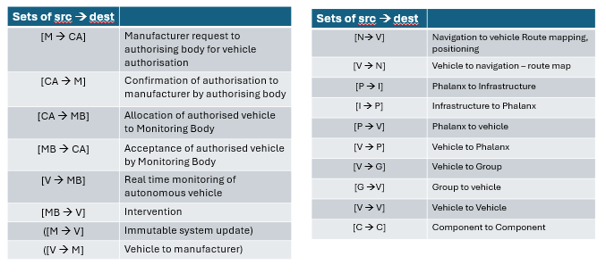

Introduction to the mathematical representation of the RTS
Utilising logic on a dynamical system, it is possible to define the possible worlds, groups, knowledge, and logics to produce a fundamental set of truths that must always hold within the representation. Effectively, this amounts to a formalisation of the RTS, an identification of the universal, distributed, and individual vehicle knowledge necessary for automated devices to operate within the system or RTS. Satisfaction of this is a first step, enabling identification of the necessary users, data, inputs, outputs, behaviours and knowledge required for implementation, before progressing to empowerment, incorporating situation awareness and knowledge, necessary for the autonomous vehicle.

There is recognition that there may always be random input from other proximate and unconnected, RTS users and devices which seeks to place the system in a position where the truth has been breached.

The mathematical representation of the RTS will comply with the Law Commissions’ recommendations (Law Commision of England and Wales; Law Commission of Scotland, 2022), and the Autonomous vehicle Bill [HL] (His Majesty's Government, 2024) and will ensure the recommendations of the Law Commissions that have an impact on the operation of the RTS are accommodated. The impacts and unintended consequences will be addressed in greater detail, in the conclusion and further in Chapter 12 Conclusion, Discussion and Further Work.

RTS mathematical representation
Using the representation defined in Chapter 2 Methodology: Mathematical Representation of Complex Systems and refining to make the generic relevant to the RTS.

This thesis relates to the autonomous vehicle within the RTS. Without full primary analysis of all elements of the RTS, it is not possible to define the full sets of ‘entity’ or ‘knowledge’ referenced in the axioms. Within this thesis, ‘entity’ describes a vehicle as in Chapter 5 The Autonomous Vehicle and ‘knowledge’ is as described in Chapter 4 Context and Structure: Knowledge; ‘interactions’, ‘relationships’ and ‘dependencies’ relate to the autonomous vehicle within the context of the RTS.

RTS generic definition
System_Boundaries :: {{Properties}, {Behaviour}}

Properties :: {{entity}, {knowledge}, {interactions}, {relationships}, {dependencies}}

Operational Domain Design
ODD ⊆ {interactions}
Dynamic Driving Task
DDT ⊆ {Behaviour}
Communicating Set
COM_SET ⊆ {relationships}
Precedence of action
PRIORITY ⊆ {dependencies}

RTS type definitions
Entity :: [Token]
Vehicle :: [Token]
Entity_State :: [Token]
Behaviour :: {[e.s e.s']}
Knowledge :: [Token]
Thing :: [Token]

pty : Property
ψ : Knowledge
g : Group
p : Phalanx
v : Authorised Vehicle
e : Entity
es : Entity.State
s : State
b : Behaviour

RTS definition transportation system
Road_Transportation_System ::
Vehicle_World :: (({{Authorised_Vehicle}, {Group, C_{G}ψ }, {Phalanx, C_{P}ψ }}, {ψ}, {ODD, DDT, {b}}, {COM_SET}, {PRIORITY}), {Thing})

RTS invariant intention
- All entities are constrained by the invariant
- All individual entity behaviour is constrained by the predefined RTS behavioural constraints
- All dynamic driving tasks of the entity are constrained by the predefined RTS set of behaviours
- The operating design domain of the entity provides a unique RTS set of interactions predefined via scenarios.
- All entity states are constrained by the predefined RTS behaviour
- A behaviour cannot map to itself as every entity state includes a temporal element that will change during evaluation of [e.s.t → e.s.t’] by ẟt

RTS invariant
((e {Entity}), ( b.e {Behaviour}), ( DDT.b {Behaviour}),
( ODD.e {Interactions}), (s {Entity_State})) .
( ! b | (([e.s → e.s']) (b ≠ [e.s.t → e.s.t])))

Conclusion
It can be seen that the boundaries of the RTS provide the context of operation for autonomous vehicles in the context of the RTS. There are similar statements attributable to the other components of the RTS, but the concentration of this thesis is in addressing the issue of scaling of deployment of autonomous vehicles and the contribution autonomous vehicles will make to the purpose and goals of the RTS.

Other components of the RTS are outside the scope of this thesis, but it is clear that similar invariants would be applicable to those components subject to anal

Almaguer-Kalixto, P. & Giglietto, F., 2019. Steering the world from where we are: An introduction to the sociocybernetics perspective. Current Sociology, 67(4), pp. 479-494. Engstrom, R., 2016. The Road's Role in the Freight Transportation System. Transportation Research Procedia, Volume 14, pp. 1443-1452. Epp, H., 2023. Tesla sacrifices to stay ahead of rivals in EV race. [Online] Available at: https://www.marketplace.org/2023/10/16/tesla-sacrifices-to-stay-ahead-of-rivals-in-ev-race/ [Accessed 17 May 2024]. Explorable.com, 2015. Participant-observation. [Online] Available at: https://explorable.com/participant-observation [Accessed 2023 April 21]. Foerster, H., 1995. Cybernetics of cybernetics: Or the control of control and the communication of communication. 2nd ed. Minneapolis: Future Systems. Heyligen, F. & Joslyn, C., 2001. Cybernetics and Second-order cybernetics. In: R. Meyers, ed. Encyclopedia of Physical Science and Technology. New Yoirk: Academic Press. His Majesty's Government, 2024. Automated Vehicles Bill [HL]. [Online] Available at: https://bills.parliament.uk/bills/3506 [Accessed 11 May 2024]. HM Treasury & National Infrastructure Commission, 2024. Chancellor commissions new study on connected and automated vehicles: Terms of Reference. [Online] Available at: https://www.gov.uk/government/publications/chancellor-commissions-new-study-on-connected-and-autonomous-vehicles-and-mobility/chancellor-commissions-new-study-on-connected-and-automated-vehicles-terms-of-reference [Accessed 15 May 2024]. Jackson Higgins, K., 2019. 19 Minutes to Escalation: Russian Hackers Move the Fastest. [Online] Available at: https://www.darkreading.com/threat-intelligence/19-minutes-to-escalation-russian-hackers-move-the-fastest [Accessed 15 May 2024]. Kherissi, F. & Meslati, D., 2010. ONTO-RUP: A RUP based approach fo r developing ontogenetic software systems. Berlin, Springer. Law Commision of England and Wales; Law Commission of Scotland, 2022. Automated Vehicles: joint report, London: Her Majesty's Stationery Office. Law Commission, 2024. Consultation Paper Aviation Autonomy. [Online] Available at: https://lawcom.gov.uk/document/aviation-autonomy/ [Accessed 12 May 2024]. Logie, J., 2020. Betamax vs VHS: The stiry of the first format war. [Online] Available at: https://medium.com/swlh/vhs-vs-beta-the-story-of-the-original-format-war-a5fd84668748 [Accessed 17 May 2024]. Matthew, T., 2019. Introduction to transportation systems: Lecture notes in Transportation Systems Engineering. [Online] Available at: https://www.civil.iitb.ac.in/tvm/nptel/101_TptnIntro/web/web.html [Accessed 6 March 2020]. Milner, R., 2009. The Space and Motion of Communicating Agents. 1st ed. Cambridge: Cambridge University Press. Mitra, A. & Scwartz, R., 2001. From cyber space tp cybernetic space: Rethinking the Relationship between Real and virtual spaces. Journal of Computer-Mediated Communication, 7(1). Mueller III, R., 2012. Speeches: RSA Cybersecurity Conference, San Francisco, CA. [Online] Available at: https://archives.fbi.gov/archives/news/speeches/combating-threats-in-the-cyber-world-outsmarting-terrorists-hackers-and-spies [Accessed 24 October 2022]. Road Networks Operations and Intelligent Transport Systems, n.d. Purpose and Objectives. [Online] Available at: https://rno-its.piarc.org/en/rno-basics-what-rno/purpose-and-objectives [Accessed 3 March 2020]. Rodrigue, J.-P., 2020. The Geography of Transport Systems. 5th ed. New York: Routledge. Sun, T., 2010. The Art of War. New York: Tribeca Books. Thales SIX UK, 2023. CLASSIFIED: Automotive Cyber Risk Assessment, Crawley: Thales. Thales SIX UK, 2024. CLASSIFIED: Automotive Cyber Security Assessment, Crawley: Thales. Umpleby, S., 2016. Second-Order Cybernetics as a Fundamental Revolution in Science. Constructivist Foundations, 11(3), pp. 455-465. Williams, N., 2023. The real reason Betamax failed spectacularly. [Online] Available at: https://history-computer.com/business/the-real-reason-betamax-failed-spectacularly/ [Accessed 17 May 2024].

